TNE20003 – Internet and Cybersecurity for Engineering Applications

**Portfolio Task – Lab 5 Credit Task**

Aims:

* To observe and investigate the functionality of the TCP and UDP protocols at the transport layer.
* Observe NAT at work and understand the translation process

Preparation:

* View [“Transport Layer Services”](https://swinburne.instructure.com/courses/54168/pages/topic-4-transport-layer-in-detail?module_item_id=3696151) & “[NAT & DHCP”](https://swinburne.instructure.com/courses/54168/pages/topic-5-dhcp-and-nat?module_item_id=3696299)

Due Date:

* All tasks in this lab are to be completed and demonstrated to your Lab instructor preferably during or at the end of the current lab, but if you do not complete the tasks you may demonstrate it at the beginning of your next lab class.

Task 1.

**Build the network provided in figure 1 with Cisco Packet Tracer**

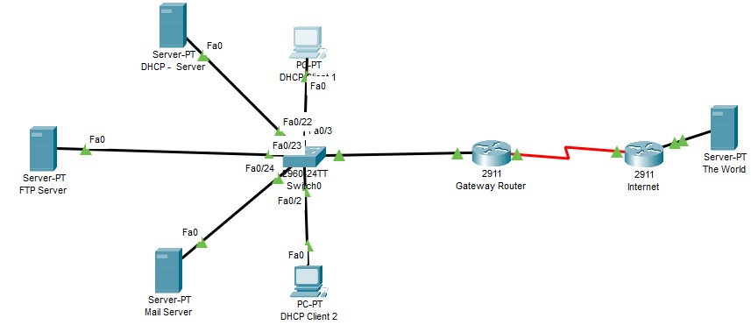

Figure 1

Use the network you built and tested in the Pass task for lab 5 to answer the following questions.

Task 2.

1. Alter the DHCP pool of addresses to 2 instead of 100.
   1. Add another DHCP Client 3 and describe what happens when this client tries to get an IP address.

Show this outcome on the simulation. What happens to the broadcast packets sent by the host seeking an IP address? invalid

* 1. What are the src and dst port numbers used? Does it make sense?

67, 68

* 1. What are the src and dst IP addresses?

Src: 0.0.0.0

Dest: 255.255.255.255

TNE20003 – Internet and Cybersecurity  Page 2

Lab 5 - Credit Task

* 1. Which transport layer protocol is being used? Explain why. UDP bcs DHCP cant use TCP bcs TCP needs both ends to have unique ip addresses.
  2. If you alter the DHCP pool of addresses to 3 and carry the request from client 3 again what happens? Why? Succesfull, bcs now the limit is 3

1. Let’s investigate the **FTP** server a little bit more.
   1. Log into the **ftp** server with username **Dragan** and password **Fire** as in the Pass task.
   2. Analyse the packet when you type “**dir**” to see what files are available for copying. What are the src and dst ports used?

Source : 1027

Dest: 21

* 1. Which part of the ftp process does this output represent? See picture below:

This picture shows after the TCP connection is succesfull and now its only transferring data.

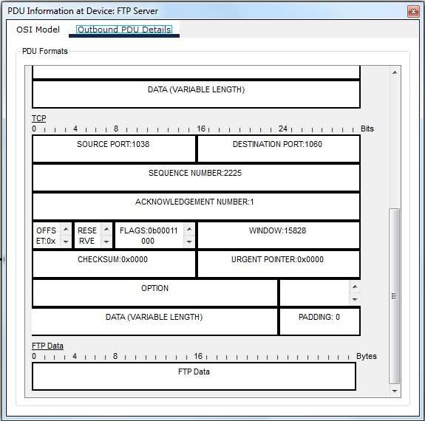

# ~~~~~ End of Lab ~~~~~

TNE20003 – Internet and Cybersecurity  Page 3

Lab 5 - Credit Task